**Escola Superior de Tecnologia e Gestão**

**Licenciatura em Engenharia Informática**

**Laboratório de Programação**

**Ano Letivo 2024/25**

**Trabalhos Laboratoriais 2**

**Elaborado em: 2024/09/23**

**Nome e número do(s) Aluno(s)**

**Índice**

List of Figures ii

1 Introduction 1

2 Fichas Laboratoriais 2

2.1 Networking Today 2

2.1.1 Initialize and reload an intermediary device 2

2.1.2 Internetwork Operating System (IOS) 2

2.2 Basic Switch and End Device Configuration 2

2.3 Protocols and Models 2

2.4 Physical Layer 2

2.5 Number Systems 2

2.6 Data Link Layer 2

3 Conclusion 2

4 References 3

# List of Figures

Figura 1‑1 – Matlab image (adapted/reproduced from [1]) 1

# Introdução

Each chapter should have a title formatted with “*Heading 1*” style. Sub-sections should be formatted with “*Heading 2*” style. If a lower level section is need, “*Heading 3*” style can also be used. Text should follow “*Normal*” style. Using a consistent style allows an easy reading, makes the navigation through the document effortless and shows a professional and organized work.

Tables and figures (such as Figura 1‑1) must be identified with the word "Tabela", "Figura", or other appropriate descriptor, and include a title and/or caption. You must use a consistent format for titles and captions of tables and figures.

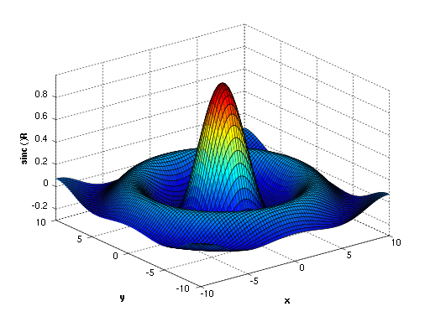

Figura ‑ – Matlab image (adapted/reproduced from [1])

Tables (such as Tabela 1), figures and other such items must be numbered consecutively in order of appearance within the report. They should be located within the chapter immediately following first reference to them.

Tabela - Characteristics of the planets (adapted/reproduced from [2])

|  |  |  |
| --- | --- | --- |
| **Name of Planet** | **Average Distance from [Sun](http://www.bobthealien.co.uk/sun.htm)** | **Diameter** |
| [Mercury](http://www.bobthealien.co.uk/mercury.htm) | 57,900,000 km (36,000,000 miles) | 4,878 km(3,031 miles) |
| [Venus](http://www.bobthealien.co.uk/venus.htm) | 108,160,000 km(67,000,000 miles) | 12,104 km(7,521 miles) |
| [Earth](http://www.bobthealien.co.uk/earth.htm) | 149,600,000 km(92,960,000 miles) | 12,756 km(7,926 miles) |
| [Mars](http://www.bobthealien.co.uk/mars.htm) | 227,936,640 km(141,700,000 miles) | 6,794 km(4,222 miles) |
| [Jupiter](http://www.bobthealien.co.uk/jupiter.htm) | 778,369,000 km(483,500,000 miles) | 142,984 km(88,846 miles) |
| [Saturn](http://www.bobthealien.co.uk/saturn.htm) | 1,427,034,000 km(888,750,000 miles) | 120,536 km(74,900 miles) |
| [Uranus](http://www.bobthealien.co.uk/uranus.htm) | 2,870,658,186 km(1,783,744,300 miles) | 51,118 km(31,763 miles) |
| [Neptune](http://www.bobthealien.co.uk/neptune.htm) | 4,496,976,000 km(2,797,770,000 miles) | 49,532 km(30,779 miles) |

The reference in the text to figures and tables must be done using the feature for “cross-references” of text editors, not manually!

# Método / Metodologia

Xxx

# Fichas Laboratoriais

xxx

## Parte 1

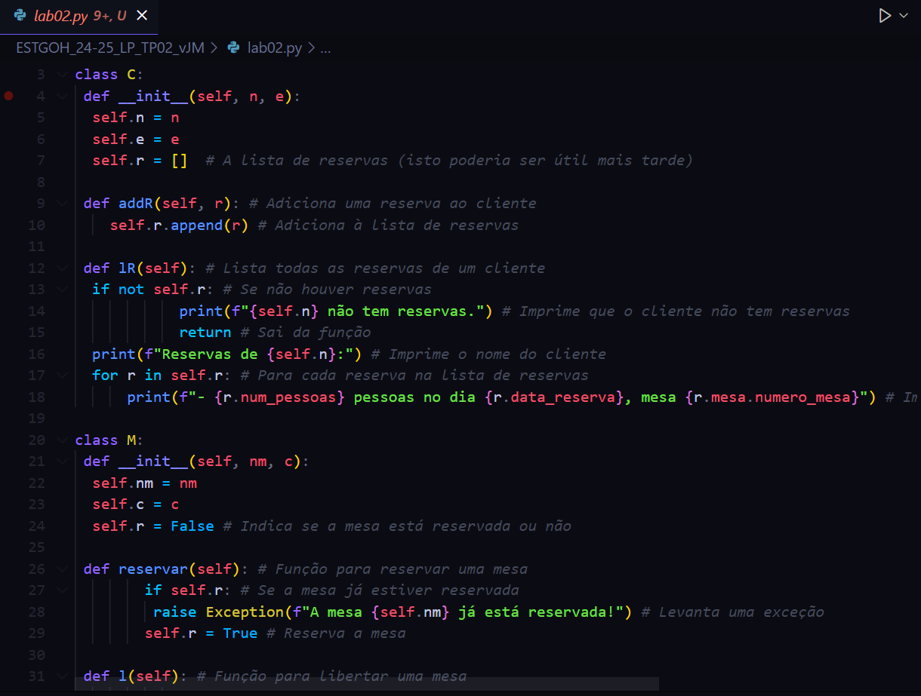

## Parte 2

## Protocols and Models

## Physical Layer

## Number Systems

## Data Link Layer

xxx

# Discussão

# Conclusão

# Referencias

References serve three primary purposes—documentation, acknowledgment, and directing or linking the reader to additional resources. The author may cite a reference to support their own arguments or lay the foundation for their theses (documentation); as a credit to the work of other authors (acknowledgment); or to direct the reader to more detail or additional resources (directing or linking). References are a critical element of a manuscript.

To manage the references, you must use a reference manager (from the built in Microsoft Source Manager to more capable and platform-independent applications such as Zotero).

There are several conventions to present references, with APA (American Psychological Association), ACM (Association for Computing Machinery), and IEEE (Institute of Electrical and Electronics Engineers) being the most

To satisfy your curiosity for the time being, you may find hints on the ACM requirements at <http://www.acm.org/pubs/submissions/submission.htm> and look up examples of the differences between the conventions of the ACM, APA, and IEEE at <http://www.library.dal.ca/subjects/csci_ref.htm>. Bellow, you are given a few examples of citations complying with the requirements of the ACM

An article in a journal:

ABDELBAR, A.M., AND HEDETNIEMI, S.M. 1998. Approximating MAPs for belief networks in NP-hard and other theorems. Artificial Intelligence 102, 21-38.

A book:

GINSBERG, M. 1987. Readings in Nonmonotonic Reasoning. Morgan Kaufmann, Los Altos, CA.

A chapter in a book:

GREINER, R. 1999. Explanation-based learning. In The Encyclopedia of Cognitive Science, R. WILSON AND F. KEIL, Eds. MIT Press, Cambridge, MA, 301-303.

An article in conference proceedings:

MAREK, W., AND TRUSZCZYNSKI, M. 1989. Relating autoepistemic and default logics. In Proceedings of the 1st International Conference on Principles of Knowledge Representation and Reasoning, Toronto, Canada, May 1989, H. BRACHMAN AND R. REITER, Eds. Morgan Kaufmann, San Mateo, CA, 276-288.